Genshin Impact.csv

Comprehensive Dataset Trend and Pattern Evaluation

1. Dataset Overview
Rows: 22255
Columns: 5

Column Details
reviewId (text): d3821eb7-de38-4697-a4df-0e6b708981ea
userName (categorical): Amrita Das
content (text): good sab
score (numeric): 5
at (datetime): 2025-06-22 23:56:39

2. Sentiment Summary
2: 12120
0: 5736
1: 4399
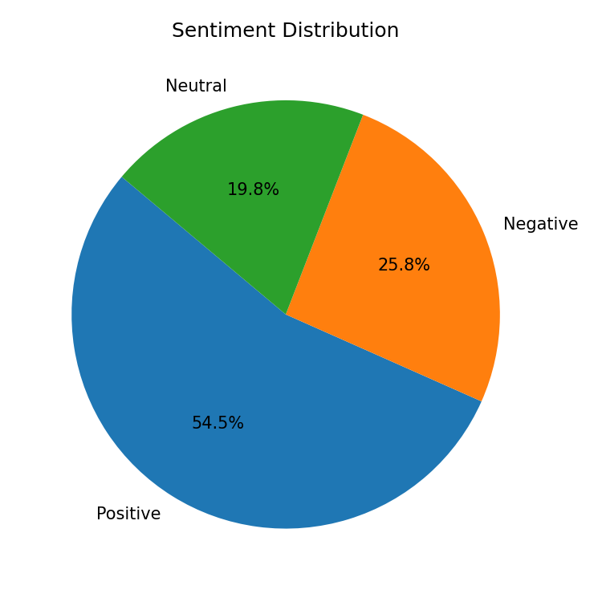

3. Key Drivers & Correlations
A strong relationship was found between Score and Content using spearman (effect=0.674, p=0, n=22255). This indicates that Score increases with Content.
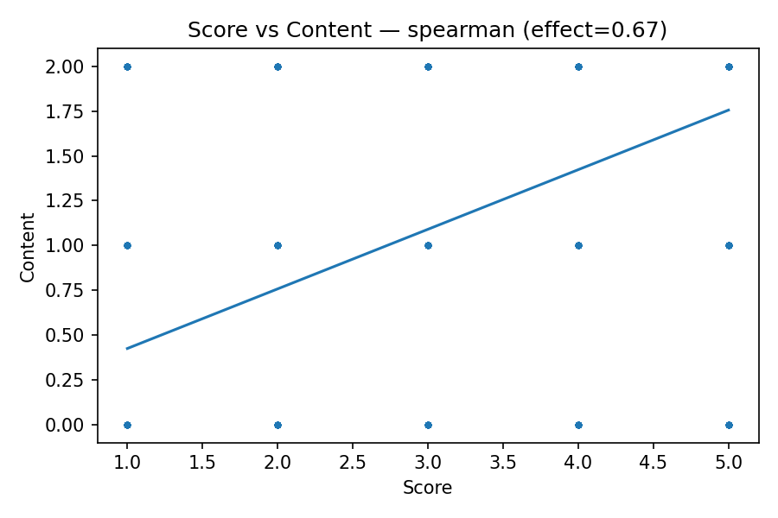

4. Summary
This analysis of 22,255 product reviews primarily aims to understand the drivers behind user satisfaction scores. The sentiment analysis of review content reveals a predominantly positive user base, with over half of all reviews expressing positive sentiment (54.46%). However, a substantial quarter of reviews are distinctly negative (25.77%), while nearly 20% remain neutral. A strong positive correlation (Spearman's ρ = 0.674) exists between the sentiment expressed in the review content and the assigned numerical score

5. Recommendations
1. Deep Dive into Negative Sentiment:** Conduct a detailed thematic analysis on the 5,736 negative reviews (sentiment `0`) to identify recurring pain points, specific feature requests, or critical bugs. Prioritize addressing the most frequently cited issues.
2. Leverage Positive Feedback for Product Development:** Extract key phrases and features consistently highlighted in the 12,120 positive reviews (sentiment `2`) to understand what users value most. Use these insights to inform future product enhancements and marketing messaging.
3. Monitor Sentiment Shifts Over Time:** Implement continuous sentiment tracking using the `at` timestamp to detect emerging issues (dips in sentiment) or successful improvements (rises in sentiment) promptly, allowing for proactive intervention.
4. Categorize Neutral Reviews:** Investigate the 4,399 neutral reviews (sentiment `1`) to determine if they represent unmet expectations, lack of strong opinion,

